1. Creating a Simple Chat with netcat in Linux by using following command:

* In device 1(as server)

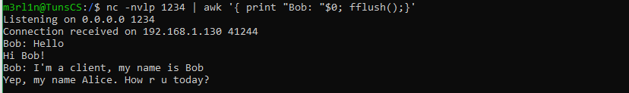

* In device 2(client)

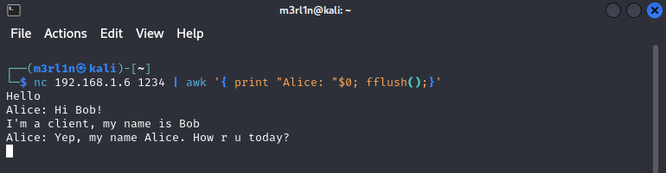

1. Use netcat to launch a webserver, in one terminal, start netcat with the following arguments -l -p 8080 .

* First we use netcat to open webserver at port 8080
* Then connect to port 8080 in another terminal
* Finally, we can see the content that type in both server and client

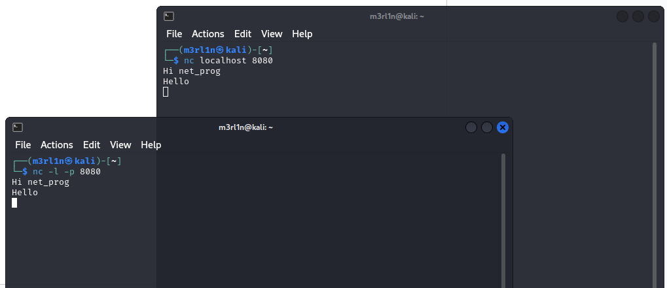

1. Write a small script that outputs a valid web page to stdout

#!/bin/bash

generate_html() {

echo -e "HTTP/1.1 200 OK\r\nContent-Type: text/html; charset=utf-8\r\n\r\n<!DOCTYPE html>\r\n<html>\r\n<head>\r\n<title>Page Title</title>\r\n</head>\r\n<body>\r\nCurrent date is: $(date)\r\n</body>\r\n</html>"

}

while true; do

{ generate_html; sleep 1; } | nc -l -p 8080 >/dev/null

done

#after we run script above, then we try to reconnect to localhost:8080 and get the date is update in everytime we reload

